**There are 5 projects each worth 20%**

Be sure to write the code and output the results

**Project #1**

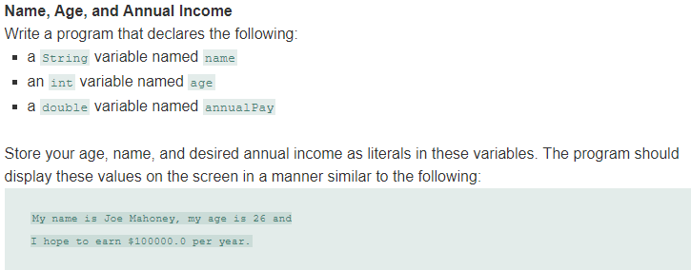

**#1 Print screen your code and results below here**

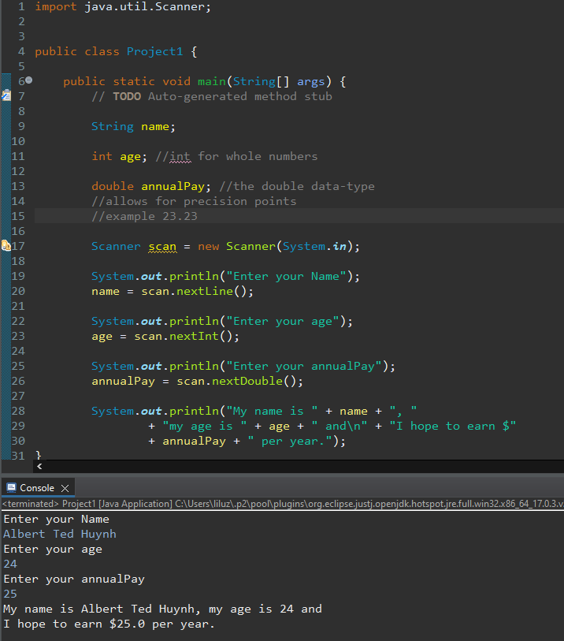

**Project #2**

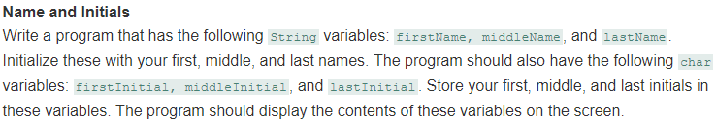

**#2 Print screen your code and results below here**

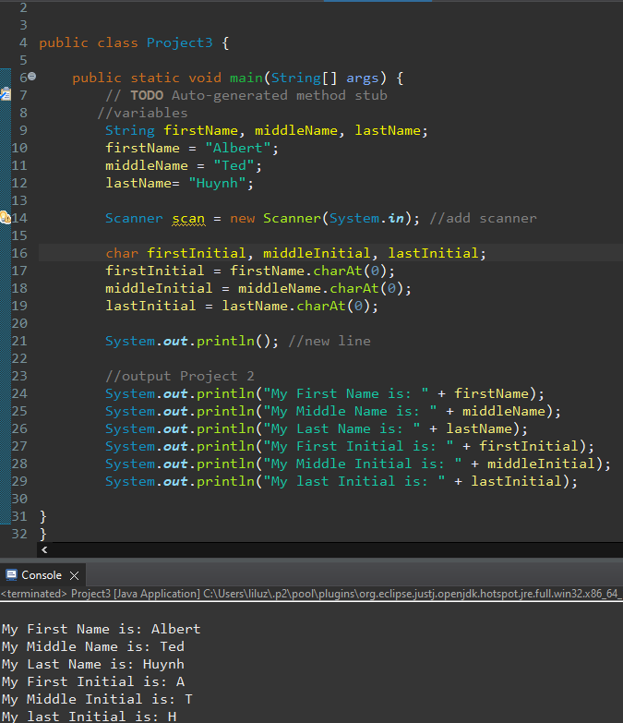

**Project #3**

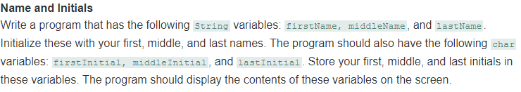

**#3 Print screen your code and results below here**

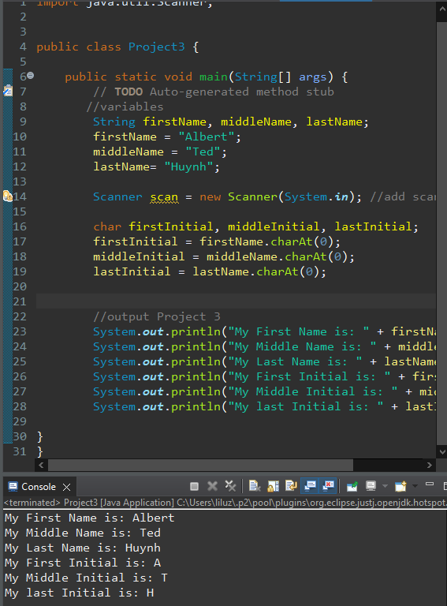

**Project #4**

Turn to page 103 and complete algorithm work bench #3

**#4 Print screen your code and results below here**

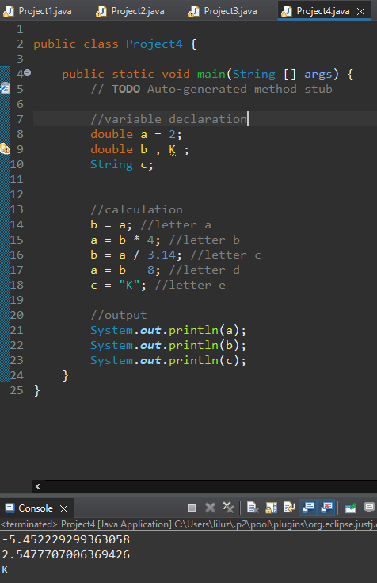

**Project #5**

Turn to page 104 and complete #11

**#5 Print screen your code and results below here**

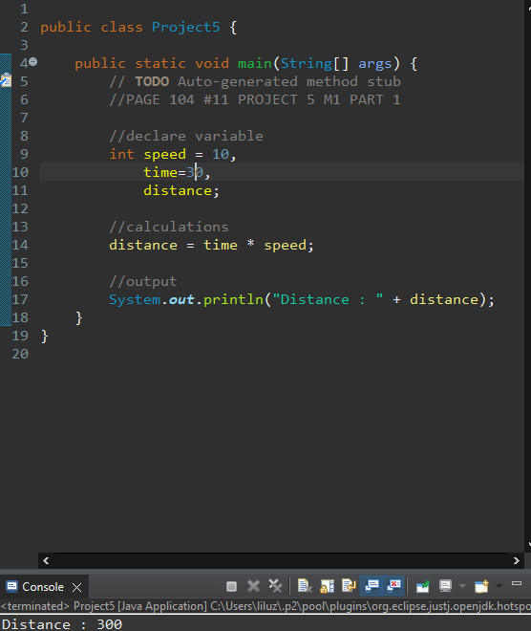

**Submit this document to Module 1 Classroom Exercise**